

MARMARA UNIVERSITY
FACULTY OF ENGINEERING

PHYS 1104.14
PHYSICS LABORATORY II
—————————————————————————————————————————
Capasitor Charge & Discharge
—————————————————————————————————————————
Section: 14

Group: 12

Instructure: Capasitor Charge & Discharge Date: 07/05/2025 8:59 am

 | Department | Student ID Number | Name & Surname
1 | Computer Engineering | 150123046 | Cihangir YAMAN
2 | Computer Engineering | 150123073 | Emir GÜDER
3 | Computer Engineering | 150123034 | Samet KURUŞ

1. Table of Contents

1. Table of Contents 2
2. Purpose 3
3. Theory 3
4. Experimental Setup 3
4.1. List Of Materials 4
4.2. Procedure 4
5. Calculations and Results 5
Part 1 5
6. Discussion and Conclusion 8
7. References 9
8. Appendix 10
Experiment Sheet 10

Calculations

Data Table
Table 2. Recorded values of voltage and current of Part I, Part II and Part IV
Part I.  R₁=10 kΩ, C₁=1000 μF |  |  | Part II.  R₂=20 kΩ, C₁=1000 μF |  |  | Part IV.  R₂=20 kΩ, C₂=2000 μF
Time (s) | $I$ (mA) | $V_{c}$ (V) | Time (s) | $I$ (mA) | $V_{c}$ (V) | Time (s) | $I$ (mA) | $V_{c}$ (V)
1 | 0.99 | 0.50 | 1 | 0.45 | 0.13 | 5 | 2.26 | 0.03
2 | 0.95 | 0.84 | 2 | 0.42 | 0.76 | 9 | 2.06 | 0.50
3 | 0.84 | 1.80 | 3 | 0.40 | 1.21 | 13 | 1.85 | 0.95
4 | 0.77 | 2.65 | 4 | 0.39 | 1.35 | 17 | 1.68 | 1.32
5 | 0.70 | 3.41 | 7 | 0.36 | 2.29 | 23 | 1.48 | 1.78
7 | 0.57 | 4.71 | 10 | 0.30 | 3.46 | 29 | 1.27 | 2.22
9 | 0.44 | 5.74 | 13 | 0.26 | 4.35 | 37 | 1.08 | 2.63
11 | 0.36 | 6.57 | 17 | 0.21 | 5.27 | 45 | 0.86 | 3.11
13 | 0.29 | 7.23 | 21 | 0.18 | 6.04 | 55 | 0.69 | 3.50
15 | 0.22 | 7.76 | 26 | 0.14 | 6.89 | 65 | 0.55 | 3.78
18 | 0.17 | 8.31 | 32 | 0.10 | 7.70 | 78 | 0.40 | 4.12
21 | 0.12 | 8.81 | 38 | 0.08 | 8.21 | 91 | 0.30 | 4.34
24 | 0.09 | 9.09 | 45 | 0.06 | 8.69 | 108 | 0.20 | 4.55
28 | 0.06 | 9.41 | 52 | 0.04 | 9.06 | 129 | 0.13 | 4.72
33 | 0.03 | 9.64 | 60 | 0.03 | 9.33 | 154 | 0.07 | 4.83
38 | 0.02 | 9.77 | 68 | 0.02 | 9.53 | 185 | 0.04 | 4.91
44 | 0.01 | 9.86 | 78 | 0.01 | 9.70 | 215 | 0.02 | 4.95
51 | 0.01 | 9.91 | 88 | 0.01 | 9.79 | 250 | 0.02 | 4.96
58 | 0.00 | 9.94 | 100 | 0.00 | 9.86 | 295 | 0.01 | 4.98
60 | 0.00 | 9.95 | 111 | 0.00 | 9.90 | 319 | 0.00 | 4.99

Table 3., Charge and discharge
- Charge |  |  | - Discharge
Time (s) | $I$ (mA) | $V_{c}$ (V) | Time (s) | $I$ (mA) | $V_{c}$ (V)
1 | 0.45 | 0.17 | 1 | 0.44 | 9.67
6 | 0.38 | 1.31 | 6 | 0.38 | 8.68
11 | 0.35 | 2.37 | 14 | 0.32 | 6.98
16 | 0.31 | 3.24 | 22 | 0.26 | 5.79
23 | 0.26 | 4.15 | 32 | 0.23 | 4.62
30 | 0.22 | 5.06 | 42 | 0.16 | 3.67
39 | 0.18 | 6.02 | 55 | 0.12 | 2.69
48 | 0.15 | 6.75 | 70 | 0.08 | 1.88
60 | 0.11 | 7.54 | 95 | 0.06 | 1.32
72 | 0.08 | 8.14 | 100 | 0.04 | 0.92
87 | 0.06 | 8.67 | 115 | 0.03 | 0.66
102 | 0.04 | 9.04 | 134 | 0.02 | 0.43
120 | 0.03 | 9.35 | 154 | 0.01 | 0.27
140 | 0.02 | 9.58 | 187 | 0.00 | 0.13
170 | 0.01 | 9.76 | 204 | 0.00 | 0.09
201 | 0.00 | 9.86 | 214 | 0.00 | 0.07

Table 4. % error of time constants
Part | Value of Voltage, Resistance and Capacitor |  |  | Time constant (τ)
Part |  |  |  | Theoretical | Experimental | % error
1 | V₁:10 | R₁:10 | C₁:1000 | 10s | 5.40s | 45.01%
2 | V₁:10 | R₂:10 | C₁:1000 | 20s | 10.74s | 46.30%
3.A | V₁:10 | R₂:20 | C₂:2000 | 40s | 17.19s | 57.02%
3.B | V₁:10 | R₂:20 | C₂:2000 | 40s | 19.41s | 51.47%
4 | V₂:5 | R₂:20 | C₂:2000 | 40s | 34.07s | 14.84%

Curves of Best Fit

To better understand behaviors of the charging and discharging capacitors in our experiment, we applied curve fitting to the experimental current and voltage data.

Capacitor Charging
The capacitors showed a nonlinear current&voltage-time relationship. When the chart is created with data gained in experiment, the line formed a curve that deviated clearly from a straight line. As shown in the formulas below (1)(2) the Current and Voltage are non-linear according to time.

$I\left(t\right)=$ $\frac{V_{s}}{R}$ $e^{-\frac{t}{RC}}$ (1)
$V_{c}=V_{s}(1-e^{-\frac{t}{RC}})$ (2)

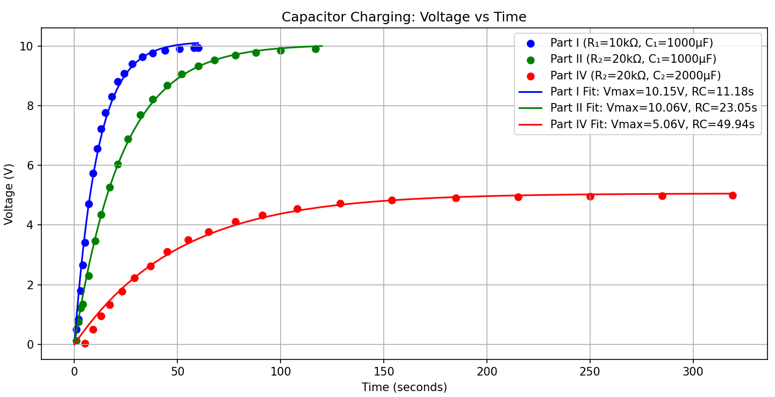
Figure 1: Part I, Part II, Part IV Charging Curves Voltage-Time

As shown in the Figure 1 above, voltage is directly proportional to time when charging capacitors. Also, as shown in the Figure 2 below, current is inversely proportional to time when charging capacitors.

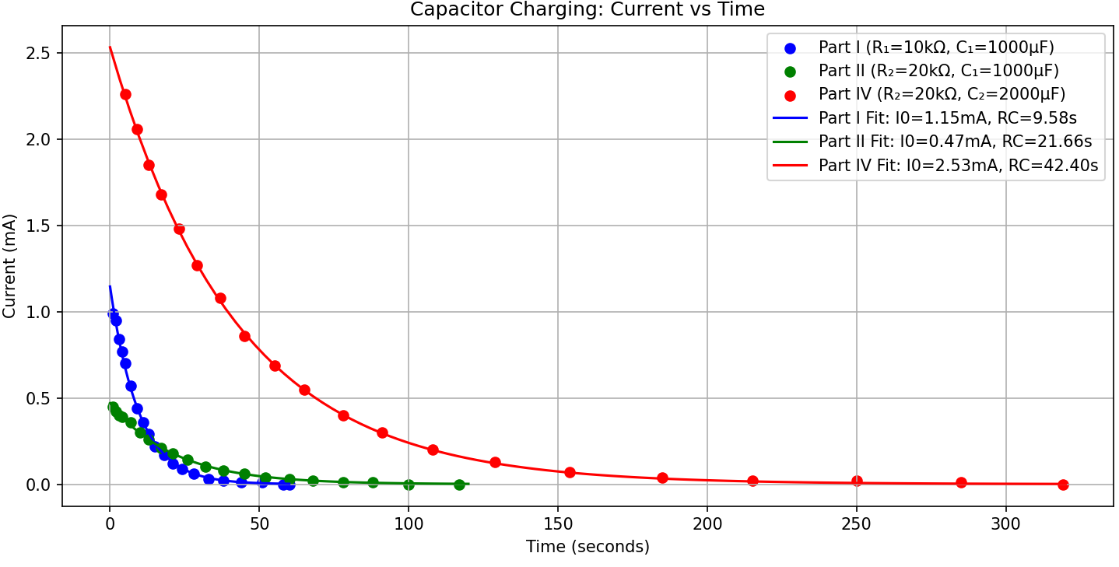
Figure 2: Part I, Part II, Part IV Charging Curves Current-Time

Capacitor Current Charging and Discharging
The capacitors showed a nonlinear current-time relationship not only when charging also when discharging. When the chart is created with data gained in experiment, the line formed a curve that deviated clearly from a straight line. As shown in the formulas above(1)(2) the current is non-linear according to time when charging and discharging.

We can clearly see in the Figure 3 and Figure 4 above, current is inversely proportional to time both when charging and discharging capacitors.

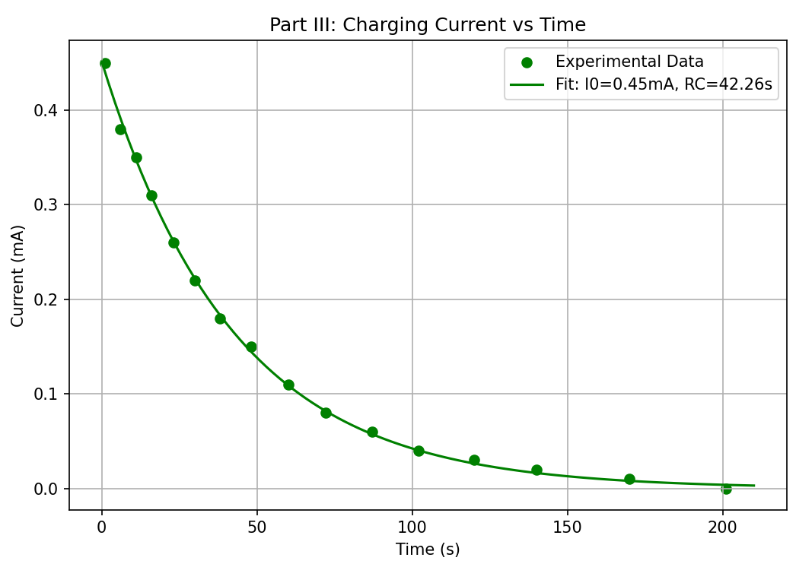
Figure 3: Part III Charging Curve Current-Time

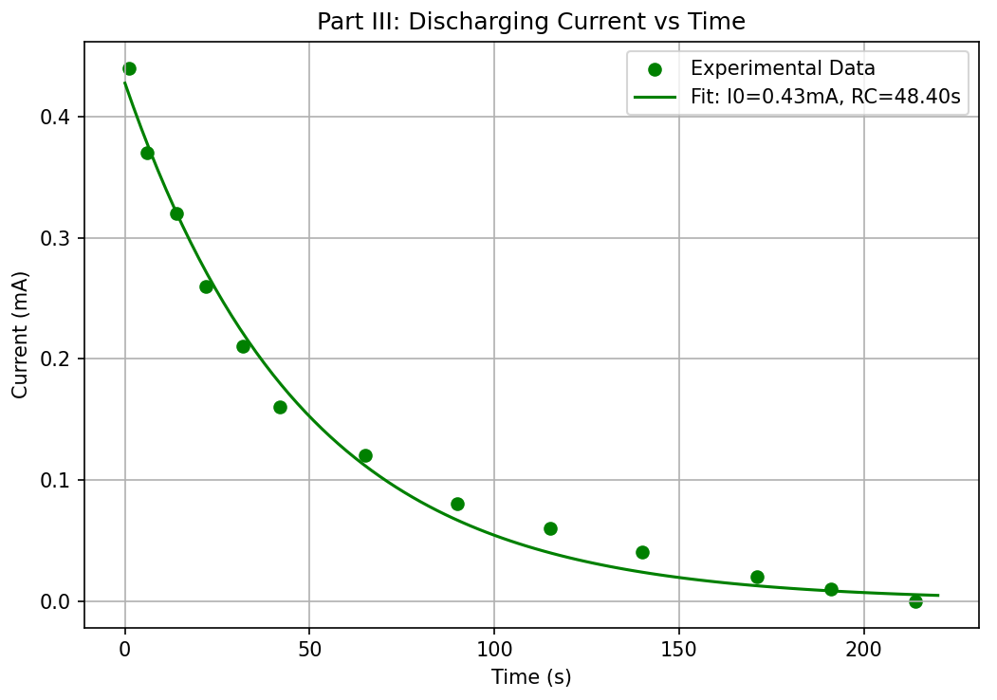
Figure 4: Part III Discharging Curve Current-Time

